**Project Development – Delivery plan sprint-4**

IoT Based Safety Gadget for Child Safety Monitoring & Notification

**TEAM ID:**PNT2022TMID07784

Creating the MIT app and Showing the child's location

**Create App in MIT App inventor:**

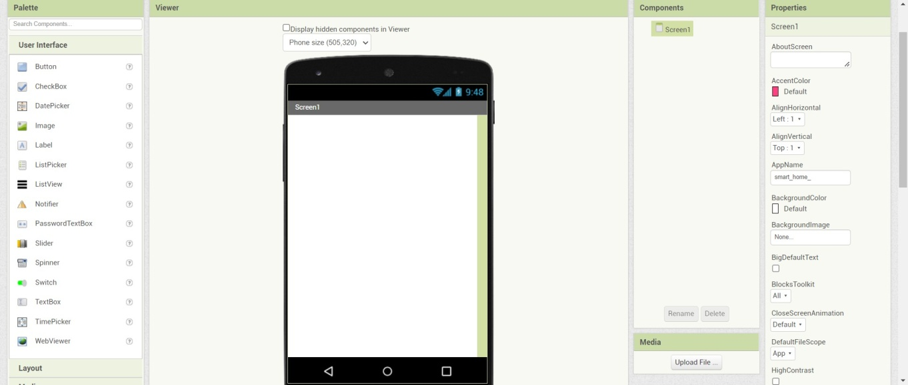

Block Configuration:

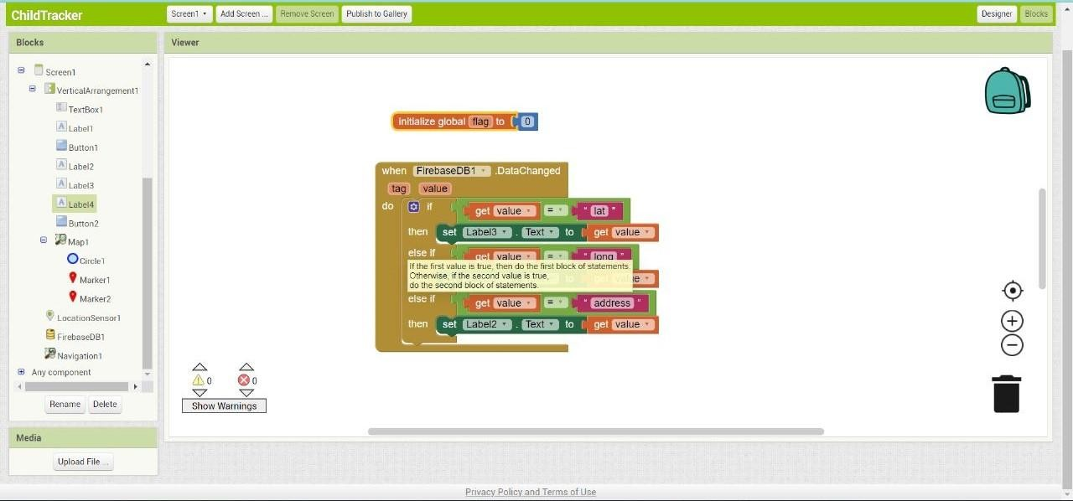

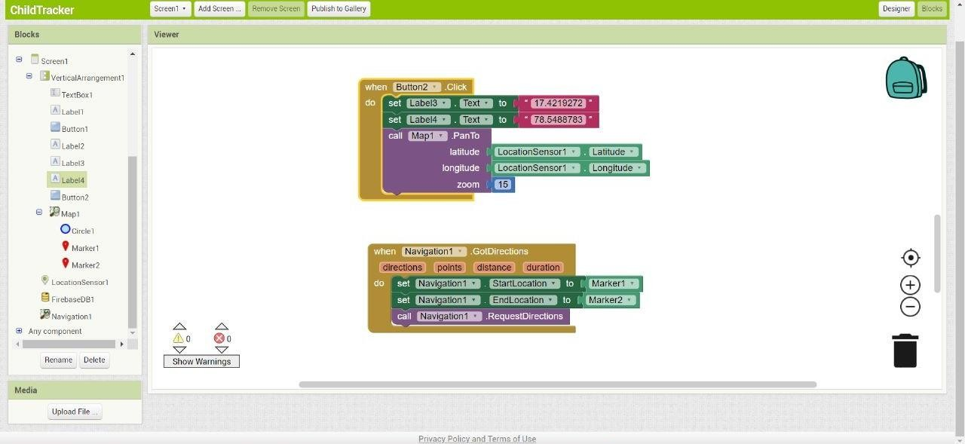

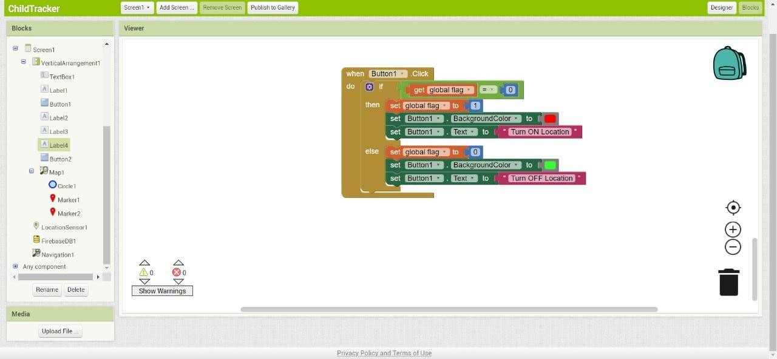

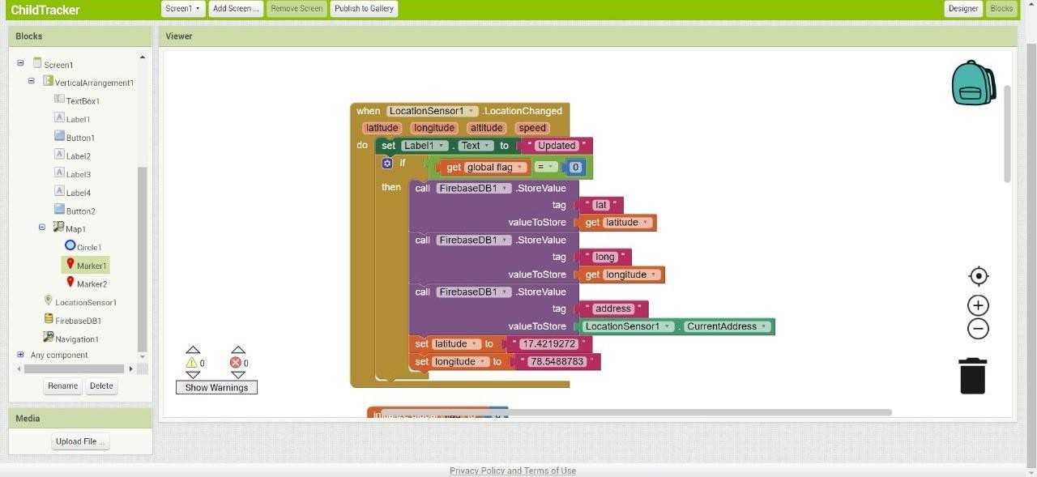

Output(App inventor):

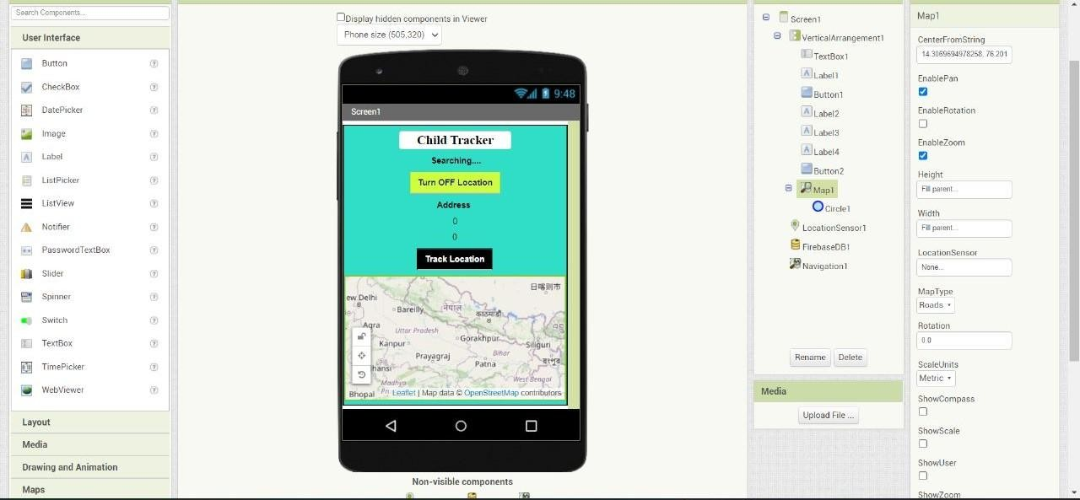

Location Status:

